2.4 Habitat Restoration
Activity Title | Date | Description (1-2 Sentences) | Metrics
Memorial Garden | Spring 2022 | The Towson High School memorial garden (dedicated in the 1980s), is the school’s main native garden, located between the lacrosse and softball fields. In 2022, the Environmental Club planned, fundraised, and planted a new group of native perennials. These include aster, common milkweed, black-eyed Susan, and goldenrod. The memorial garden is used by the school community for instruction about the benefits and properties of native species and pollinators.  Pictures below show the planting of the memorial garden  Link to Planning PowerPoint:  2022 Native Garden polls and plans.pptx

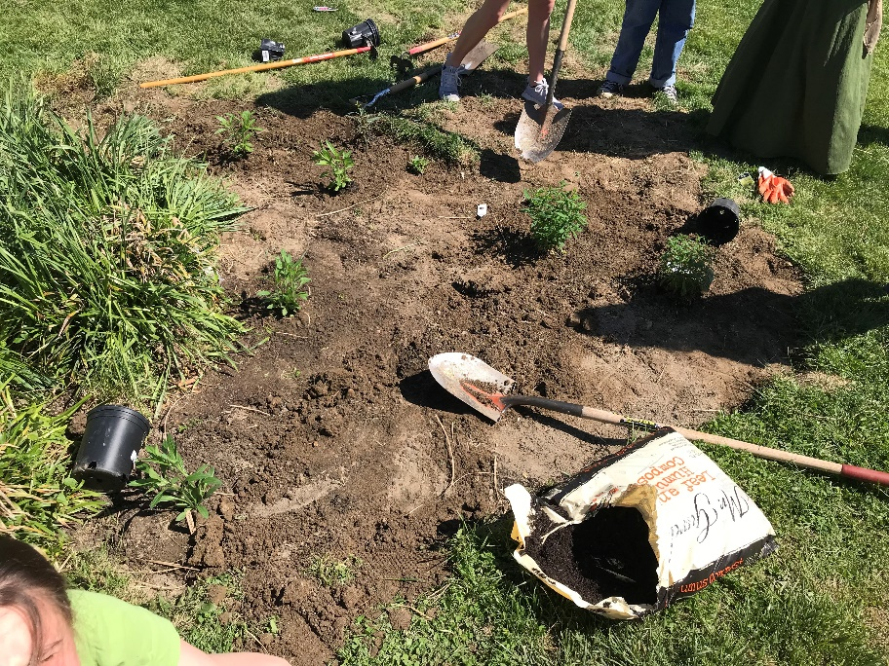
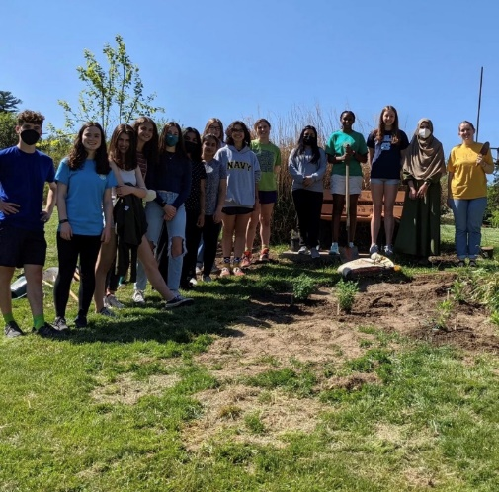
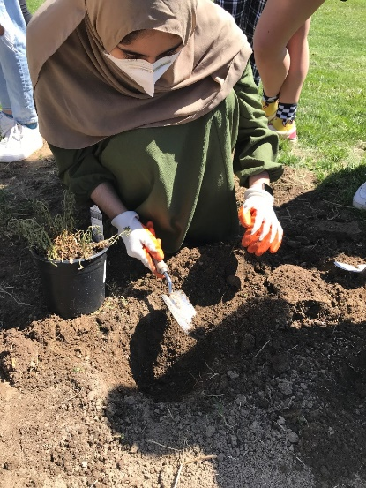
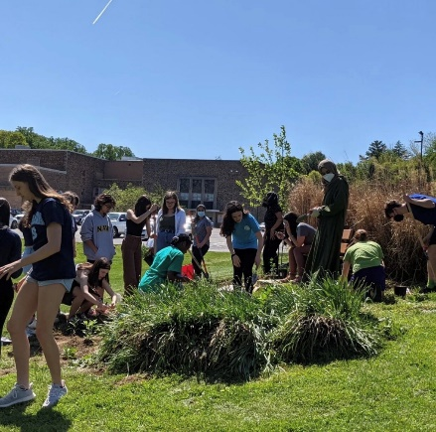
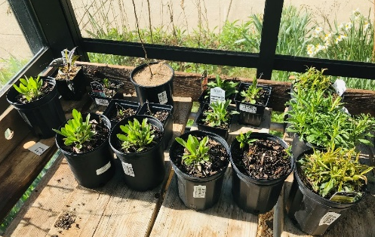
v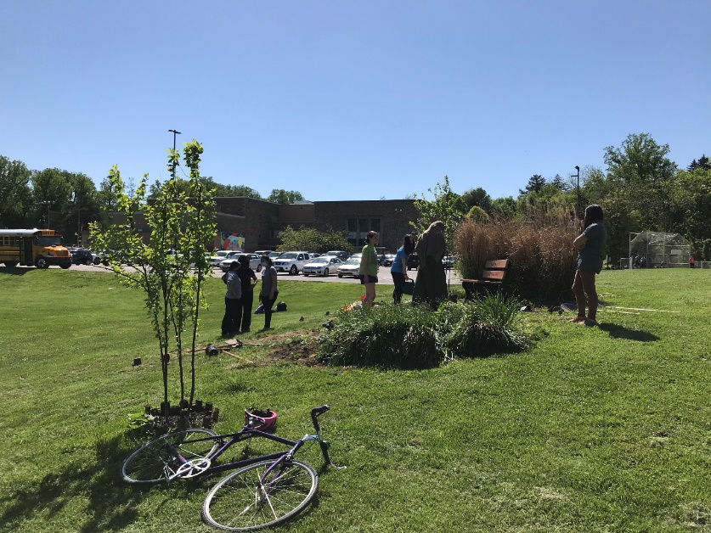
Students planting native Maryland perennials in the Memorial Garden

